
Westminster International University in Tashkent

Development of an AI-Based Speaking Assessment System Using Text-to-Speech (TTS), Speech-to-Text (STT), Pronunciation Assessment, and AI-Generated Feedback.

A Thesis submitted in partial satisfaction of the requirements for
the degree of Master of Science in Business Intelligence and Analytics

by
Student: Sarvinoz Mamatqulova (002277)
Supervisor : Mukhammadmuso Abduzhabbarov

2026

TABLE OF CONTENTS
Contents
Acknowledgments 3
Abstract 4
1. Introduction 5
1.1 Introduction to the Study 5
1.2 Statement of the Problem 5
1.6 The Importance of the Study 7
2. Literature Review 8
2.1 Introduction 8
2.2 Speech Technologies 9
2.3 Speech and Pronunciation Assessment 11
2.4 TTS and ASR in Language Learning 14
2.5 Feedback Systems Based on LLMs 16
2.6 Comparison to Previous Studies 18
2.7 Gaps in the Literature 20
3.Methodology 22
3.1 Research methodology 22
3.4 Text to Speech (TTS) Module 26
3.7 Predicting the Score in IELTS Style 29
3.8 AI-generated feedback 31
3.9. System Validation 32
3.10 Ethical Considerations 34
4.Results 34
4.1 Results of system tests 34
4.3 Results of Transcript Analysis 40
4.4 Results of AI Feedback 41
4.5 System Changes and Enhancements 43
5.Discussion 44
5.1 Findings Discussion 44
5.2 Comparisons with Previous Studies 45
5.3 Advantages of Proposed System 47
5.4 Problems and Difficulties 47
5.5 Study Limitations 48
5.6. Future Research 49
6.Conclusion 50
7.References 52

Acknowledgments
I would like to offer my heartfelt thanks to my supervisor mabduzhabbarov@wiut.uz for his advice, support and useful feedback during this project. His guidance and support were crucial in enabling me to complete this dissertation.
I would also like to thank my institution and teachers for the knowledge, learning atmosphere and tools that helped me in my academic path.
I am particularly thankful to my family members for their constant support, patience and encouragement during the process of completing this study. Their inspiration allowed me to stay focused and to overcome hurdles during my research.
Finally, I would like to thank all those who have helped, directly or indirectly, in the preparation of this dissertation.
Thanks.

Abstract
Artificial Intelligence (AI) is gaining importance in language-learning systems, notably to improve speaking skills. Traditional methods for assessing speaking skills can be limited because students may not get rapid feedback or enough chances to practice speaking individually. Thus AI-based technology can help to deliver more productive learning experiences.
In this study, we offer an AI-based speaking evaluation system that integrates the Text-to-Speech (TTS), Speech-to-Text (STT), the pronunciation assessment, the analytical score prediction, and the AI-generated feedback in one system. The application was built using Flutter and connected to voice technology for speaking practice and assessment.
The system enables learners to listen to model pronunciation, record their responses, analyze their speaking performance and receive tailored feedback. The rating method looks at many aspects of speaking such as pronunciation accuracy, fluency, pauses and confidence levels. The system also provides feedback and suggestions for improving the trainees’ speaking skill.
The results show that the integration of speech technologies and AI-based feedback can facilitate speaking assessment and foster a more interactive learning experience. However, some issues remain such as Speech recognition accuracy and Reliability of AI-generated feedback.
Key words:
Artificial Intelligence, Speech Recognition, Text-to-Speech, Pronunciation Assessment, Language Learning

1. Introduction

1.1 Introduction to the Study
Artificial Intelligence (AI) has entered the modern classroom, particularly when it comes to language instruction. In recent years, AI-based solutions have been employed to assist learners with individualized practice, automatic feedback, and interactive learning systems. One area where AI has been very helpful is speaking practice and speaking assessment.
Thus, this work develops an AI-based speaking evaluation system by integrating Text-to-Speech, Speech-to-Text, pronunciation assessment, analytical IELTS-style score prediction, and AI-generated feedback. The system was developed to allow learners to practice speaking, receive feedback, and track their development over time.

1.2 Statement of the Problem
Speaking is one of the most important abilities in language acquisition since it helps learners to articulate ideas, communicate with people and utilize the language in real circumstances. But learning to talk is hard for many learners. Common concerns are bad pronunciation, lack of fluency, small vocabulary, grammar faults and low confidence. These challenges are typically hard to tackle in traditional classroom settings since teachers don't have enough time to give specific feedback to every student.
Speaking assessment is typically carried out by human teachers or examiners. Human evaluation is useful, but it can be time-consuming and may not always be consistent, especially if many students need to be tested. Learners may also not get feedback immediately after speaking, which might slow down improvement. This has led to an increasing interest in the use of AI and voice technology to support speaking assessment.
Speech technologies like Text-to-Speech (TTS) and Speech-to-Text (STT) can offer diverse language learning help. The TTS helps the learners listen to the model pronunciation while the STT transcribes the spoken language into text for further examination. When paired with pronunciation assessment and AI-generated feedback, these technologies can give learners more detailed information about their speaking performance.
Recent advances of Large Language Models (LLMs) also presented new potential for feedback production. Traditional systems primarily provide scores, while LLMs can generate explanations, suggestions and individualized recommendations. This is helpful for learners as they may learn not just what score they got but why and how they can better.
But many current speaking apps are still devoted to individual functions. Some systems offer mostly voice recognition; others merely provide pronunciation ratings or simple feedback. However, a more integrated solution is still needed that combines speech recognition, pronunciation analysis, score prediction, feedback generation and progress tracking under one platform.
Speaking assessment is still a difficult subject in language learning since it demands the assessment of a number of features at the same time such as pronunciation, fluency, vocabulary, coherence and confidence. It is impossible for teachers to offer detailed and instantaneous spoken feedback to each learner in typical learning situations.
The use of AI in language-learning systems is more popular, yet many of the present systems have limitations. Some programs prioritize speech recognition above comprehensive pronunciation analysis. Some give ratings but do not adequately explain the faults the student makes. Moreover, some systems do not track the progress of the student across several trials.
Another key question is the dependability of automated assessment. Learners’ speech may include accents, pauses, pronunciation variances and grammatical faults. These factors may impair the accuracy of speech recognition, and may reduce the dependability of automated scoring. In the development of this project, it was also found that very short speaking responses could lead to incorrect results as there was not enough voice data to analyze for meaning.
Therefore, an AI-based speaking assessment system that integrates voice technology, pronunciation analysis, score prediction and personalized feedback in a more thorough and practical way is needed.
1.3 Aim of the study
The purpose of this research is to design a speaking assessment system based on AI that combines voice technology, analytical score prediction, and AI-generated feedback for English speaking practice and assessment.
1.4 Research objectives
The objectives are:
1. Develop an AI-powered speaking assessment application for English speaking practice.
2. To implement Text to Speech and Speech to Text technologies to the system.
3. To analyze learner’s speech pronunciation, fluency, vocabulary, coherence and pause related factors.
4. To develop IELTS style speaking predictions from retrieved speech features.
5. To give AI produced comments and recommendations to learners.
6. Test the system with student users and assess the outcomes.
1.5 Research Questions:
The research questions to be addressed in this project are:
1. How may speech technology assist in automated speaking assessment?
2. How may learner speech traits be utilized to predict IELTS-type speaking?
3. What are the ways AI-driven feedback might help learners' speaking practice?
4. What are the hurdles in designing and testing AI based speech assessment system?

1.6 The Importance of the Study
The significance of this study is that it provides a functional AI-based system for speech assessment and feedback. The system combines a number of technologies into one platform including Text-to-Speech, Speech-to-Text, pronunciation analysis, IELTS-style score prediction and AI-generated feedback.
The system can give the learners more opportunities to practice speaking on their own. This allows learners to record their speech, get instant feedback, and track their improvement over time. This can assist learners to become more aware of their speaking skills and faults.
The technology can help teachers with speaking practice, by decreasing the need for continual manual feedback. The technology cannot replace a human teacher, but it can be used as a supplementary learning tool.
This study is relevant in the area of Business Intelligence and Analytics as it gathers and examines learner performance data. The system provides feedback on student performance based on speech features and assessment results to facilitate data-driven decision making in language acquisition.
1.7 Limitation of the Study
This work refers to the construction and evaluation of the AI-based speaking assessment system for the English-speaking practice. The technology analyzes learner speech and gives predictions and feedback in the style of IELTS speaking.
The study is concerned with speaking-related aspects in the first place, such as pronunciation, fluency, vocabulary, coherence, prosody, pauses and speech tempo. It does not test other language abilities such as reading, writing or listening.
The system was tested on over 30 pupils. The results are utilized to evaluate the functionality of the system and observe the performance patterns of learners. But the research doesn’t say the algorithm can replace the official IELTS speaking exam or the expert human review.
1.8 Structure of the dissertation
The dissertation is comprised of six chapters.
Chapter 1 introduces the backdrop of the study, problem statement, aim, research objectives, research questions, significance of the investigation, and scope of the study.
Chapter 2 presents the literature review on voice technology, pronunciation evaluation, AI-based learning systems and LLM-based feedback
Chapter 3 describes the technique used to design, build and assess the system
Chapter 4 summarizes the results of the test of the application with student users.
Chapter 5 reveals the results, problems, limitations and future enhancements.
Chapter 6 finishes the dissertation with a summary of the key findings and contribution of the study.

2. Literature Review

2.1 Introduction
Artificial Intelligence (AI) has already become common in education, particularly in language learning. Many modern learning systems incorporate AI to offer automatic evaluation, individualized feedback, and interactive learning experiences. Speaking assessment is an issue that has gotten a lot of attention, as speaking is frequently thought to be one of the most challenging language skills to learn and assess. Increasingly, researchers have utilized speech technologies, such as Text-to-Speech (TTS) and Speech-to-Text (STT), to enhance speaking practice and assessment. TTS enables learners to hear the right pronunciation, whereas STT translates the speech into text for analysis. These technologies have provided new chances for assisting learning of students out of the classroom and delivering quick feedback. At the same time, advancement in the pronunciation-evaluation systems and Artificial Intelligence has enabled the autonomous assessment of learner speech. More recently, Large Language Models (LLMs) have been leveraged to generate fine grained feedback and suggestions instead of scores alone. This way, learners get more individualized support and have a better understanding of their strengths and shortcomings in speaking. Although there are many studies on voice technologies and AI based learning systems, yet there are several challenges. Most of the present systems are not a complete learning solution but rather are based on a single function such as speech recognition or pronunciation rating. Apart from that, the performance of the system still suffers from concerns such as evaluation accuracy, feedback quality, and non-native speech recognition. Therefore, it is vital to review previous research to understand the strengths and limits of present methodologies. This chapter discusses relevant work in voice technology, pronunciation evaluation, AI-supported language learning, and LLM-based feedback systems. It also highlights the research gap that led to the development of the proposed AI-based speaking assessment system.

2.2 Speech Technologies

TTS, STT and Speech Technologies are a significant feature of modern language learning systems since they assist learners to practice pronunciation and get automatic assessment. The most popular speech technologies are Text to Speech (TTS) and Speech to Text (STT). TTS transforms written text to spoken speech, STT converts spoken speech to text. These technologies together allow students to listen, talk and receive feedback in the same learning environment.
The advent of neural speech synthesis was one of the most major advancements in TTS technology. Neural models, including Tacotron and WaveNet, achieved a substantial increase in the quality of generated speech compared to traditional rule-based systems (Tan et al. 2021). Previously, speech synthesis systems generally generated robotic and artificial speech, which limited their usage in language learning contexts. In comparison, the neural models produced speech that was considerably more like natural human speech.
Tacotron became one of the most influential TTS models as it presented an end-to-end approach to speech synthesis . Instead of many manually created rules, the model automatically learnt the association between text and speech. This led to more natural speech and more realistic pronunciation examples for the learner.
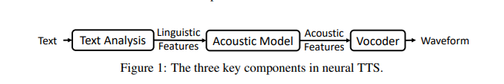
Figure 2.1 Tacotron Architecture (taken from Tan et al . 2021)
Tacotron made voice quality much better, but it also created several issues. The model needs a lot of training data and computing power. That means, although Tacotron is good for natural voice generation, its implementation can be more difficult for lightweight educational applications with rapid processing and lower resource use.
WaveNet was another big step forward in voice synthesis. Whereas prior techniques created speech using specified units, WaveNet synthesized speech waveforms directly. This led in more natural and lifelike speech output.
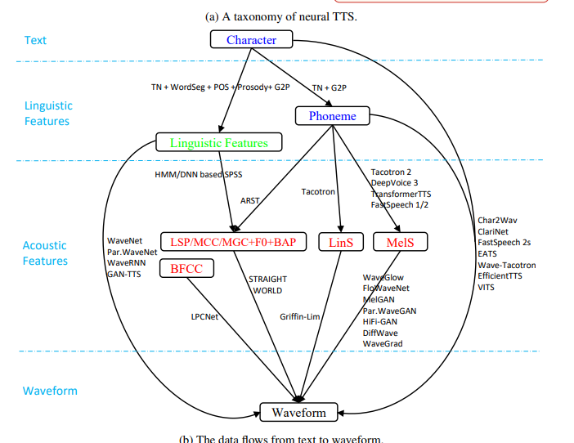

Figure 2.2 WaveNet Speech Generation Process (modified from Tan et al.2021)
However, the improvement in voice quality came at the expense of greater computing complexity. Wavenet presented a great performance but with processing needs that made real-time deployment more difficult. Therefore, researchers are still looking for models that offer a good balance between voice quality and computing efficiency.
While TTS technologies are concerned with producing speech, STT technologies are concerned with interpreting learner speech. STT systems today use neural networks to recognize spoken language and translate it into text . These systems have achieved good identification accuracy in several applications like virtual assistants, customer-service systems and educational platforms.
“Speech recognition remains a challenging task in language-learning environments, despite these advances. Learners’ speech sometimes incorporates pronunciation problems, pauses, hesitations and variations in accent. These features can hamper the recognition accuracy and influence the dependability of automated assessment. Consequently, the voice recognition performance for non-native speakers is generally worse than for native speakers.
This is a serious constraint as the transcript quality is of a critical importance for the speaking assessment systems. If learner speech is misrecognised, then subsequent stages of analysis and feedback creation may likewise be less accurate. Thus, the efficacy of automated speaking assessment depends not only on the assessment algorithms, but also on the quality of the speech recognition system.
The link between TTS and STT is significant in language learning applications. TTS enables learners to hear correct pronunciation and gives speaking examples. STT enables learner speech to be analysed and assessed. Historically, these technologies were generally studied separately, but modern educational institutions are gradually integrating them together on a single platform. This integration allows learners to transition from listening and speaking practice to automatic evaluation and feedback in the same environment.
The review of existing literature indicates that TTS and STT technologies have created new potential for language learning and speaking assessment. They are the cornerstone of many AI-driven educational systems and allow for more engaging learning experiences. But the computing needs, voice-recognition accuracy and non-native speech processing problems are there. The constraints identified indicate the necessity for integrated systems that combine speech technology with assessment and feedback mechanisms, which is the method taken in this work.

2.3 Speech and Pronunciation Assessment

Pronunciation is one of the most significant parts of speaking skill since it directly influences communication and intelligibility. Even if you have a solid mastery of grammar and vocabulary communication may be tough if you do not pronounce things clearly. Therefore, pronunciation assessment has become an essential research field in language learning and voice technologies.
Traditionally, pronunciation has been assessed by teachers or examiners. Human evaluation can be a source of rich input, but it is often slow and can vary amongst evaluators. Therefore, more and more efforts have been made to study automatic pronunciation-assessment systems which can help to make the evaluation more quickly and reliably. Early automatic pronunciation-assessment systems were mostly concerned with individual speech aspects, e.g., pronunciation accuracy or phoneme recognition . The computers offered useful information but typically made judgments about speech using a narrow set of signs. This was a problem since several elements might affect speaking performance such as pronunciation, fluency, pauses, stress patterns and overall voice quality.
To overcome this restriction, more recent works suggest multi-feature assessment methods . An example is the HiPAMA framework developed by Do, Kim and Lee (2022). The model employs hierarchical attention processes to process multiple features of learner speech simultaneously. Instead of outputting a score based on one feature, the framework examines the different speech features and their relations.
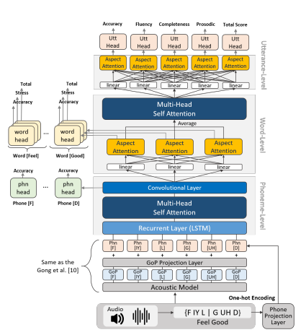
Figure 2.3 HiPAMA framework (Do, Kim and Lee, 2022 modified)
HiPAMA is not just important for the technological design, but also for the philosophy of assessment. The study reveals that pronunciation should not be measured in isolation because speaking performance is influenced by a number of interconnected elements. This is an idea that is especially significant in educational applications where learners need more detailed evaluation than just a score for pronunciation. However, the model suffers from the increased computing complexity, which may hinder its deployment in the lightweight learning systems.
Similarly, Chao et al. (2022) claimed that pronunciation assessment should consider speech at several levels, i.e., individual sounds as well as the whole utterance. Their findings indicate that learners may perform well at one level but struggle at another. This underlines the need to consider many speech aspects for assessment, rather than depending on a single indicator.
A further key advance in speech assessment is the increasing use of Large Language Models. Previously, systems would typically just provide a number score without showing the learner why they made a mistake. As a result, students could see their scores but didn’t always know how to improve. Recent studies have attempted to tackle this challenge by integrating pronunciation analysis with AI-generated explanations.
Chen et al. (2025) proposed TextPA, a system that blends LLM reasoning and speech recognition. Unlike standard pronunciation evaluation systems, TextPA is designed to clarify learners’ faults and give individualized recommendations. This signifies a major change from score-based assessment to learner-focused feedback.
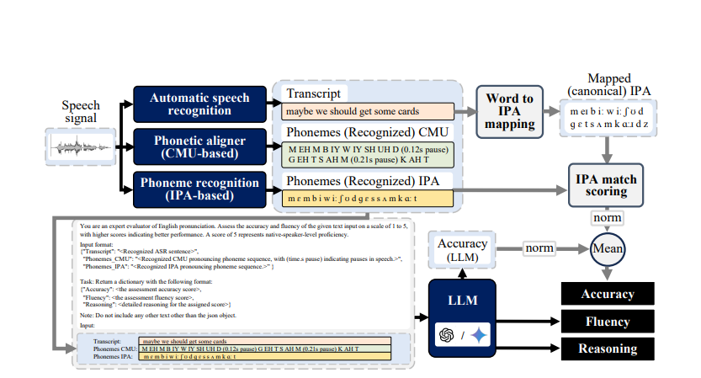
Figure 2.4 TextPA Framework (Source: Chen et al., 2025)
TextPA's key benefit is that it may provide useful explanations, not merely evaluation scores. Learners are more likely to profit from criticism if they have a clear sense of why they make errors and how they may improve. But the usage of Large Language Models also brings additional issues. Sometimes, feedback generated by AI can be repetitive, inconsistent or erroneous. LLM-based systems can offer useful learning aids, but they should be utilized judiciously and validated often.
When comparing HiPAMA and TextPA, it can be observed that the two frameworks are both aimed at improving pronunciation assessment but with distinct focus. HiPAMA aims to improve the accuracy of speech evaluation based on advanced acoustic analysis, while TextPA aims to improve the quality of feedback based on language-model reasoning. This comparison is an example of a larger trend in research on pronunciation assessment. Previous studies have focused on improving the scoring accuracy. However, subsequent studies have increasingly focused on the quality of feedback and learner’s support.
While a lot of progress has been made, there are still a number of limitations in the present pronunciation-assessment systems. Most models just focus on pronunciation and ignore other aspects of speaking such as vocabulary, coherence, confidence, etc. Additionally, many studies perform evaluation of models in controlled conditions, while real-life language-learning situations sometimes include accents, hesitations, background noise and different speaking abilities.
These constraints are substantial, as effective speech assessment involves more than simply precise rating of pronunciation. Learners also require feedback they can understand, opportunities to practice repeatedly, and the capacity to track their progress over time. This increasing demand is leading to a need for integrated systems comprising pronunciation assessment, voice analysis, feedback production and monitoring of student progress in a single platform.
Overall, past research indicates that pronunciation-assessment systems have become increasingly sophisticated and learner-centered over time. The research has evolved from simple pronunciation rating to multi-feature evaluation and customized feedback. However, there are still issues in terms of reliability of evaluation, quality of feedback and integration with the system. These limitations provide a solid justification for the development of the AI-based speaking assessment system presented in this study.

2.4 TTS and ASR in Language Learning

In recent years, the usage of Text-to-Speech (TTS) and Automatic Speech Recognition (ASR) technology in language acquisition has increased dramatically. These technologies have attracted increasing attention among researchers as they enable learners to practice speaking autonomously and obtain quick feedback without relying fully on lecturers. Therefore, TTS and ASR are currently widely employed in pronunciation training, speaking practice applications and intelligent teaching systems. One of the key benefits of TTS technology is that it offers learners consistent patterns of pronunciation. In the classroom, learners may have limited listening practice opportunities to hear native or standard pronunciation, while TTS systems offer unlimited hearing practice. Khalid and Muhammad (2014) suggested that regular exposure to proper pronunciation could make the learners more comfortable with the speech patterns and increase the pronunciation accuracy with the passage of time. This is especially valuable for learners who have few opportunities to interact with native speakers. But only hearing the correct pronunciation doesn’t ensure speaking progress. Learners require opportunities to generate speech and receive feedback. And here is where ASR technology comes in. ASR systems can automatically analyze learner speech and provide information about pronunciation performance. The combination of TTS and ASR allows a complete practice cycle where learners can listen, talk and get feedback.Kouidri (2025) studied the efficiency of the combination of TTS and ASR technologies for learning English. The study indicated that, in general, learners appreciated the early feedback since it enabled them to discover pronunciation errors more rapidly. The research showed that the immediate feedback after speaking exercises made learners more conscious of their faults. This result is consistent with the assumption that feedback is vital in language learning. Similarly, Jia and Zhang (2018) researched AI-based pronunciation feedback systems and underlined the significance of correction feedback. The authors suggest that immediate feedback allows learners to identify errors before they are embedded in improper speech habits. However, they also said that automated feedback should supplement rather than replace teacher advice, since technology may not always be able to pinpoint the root reasons of student mistakes.
Another key benefit of TTS and ASR technologies is the rise in the learner’s confidence. When many kids speak in front of teachers or classmates they are frightened because they are scared they will make mistakes. Zou et al. (2021) contended that AI-based speaking tools may alleviate such worry by offering a private space for practice. Learners may repeat speaking tasks several times without feeling ashamed, which can lead to greater involvement and speaking confidence.
However, the advantages of past investigations have uncovered several drawbacks. One of the most typical problems is voice recognition accuracy. While modern ASR systems have made great progress, this progress this progress may not be sufficient to handle non-native speech, heavy accent or pauses and pronunciation problems. This can lead to mis transcriptions and lower the trustworthiness of generated feedback. This means that the quality of the assessment is typically very dependent on the accuracy of the speech recognition.
Another disadvantage is that many language learning apps tend to focus on pronunciation correction, and do not test broader speaking skills. Speaking skill is not only a matter of correct pronunciation, it also entails fluency, vocabulary, coherence and the capacity to transmit ideas effectively. Systems that concentrate primarily on pronunciation may consequently give an inadequate picture of student performance.
Comparing the results of the prior investigations, one may see a general pattern. Most scholars agree that TTS and ASR technologies can facilitate speech practice and promote student engagement. However, there is less consensus on their ability to provide holistic speaking assessment. Some research finds beneficial learning effects, while others show the limits of automated feedback and speech-recognition accuracy.
These results indicate that TTS and ASR technologies are useful tools for language learning but are most effective when paired with other assessment and feedback methods. These tools should not be used in isolation, but as part of a comprehensive learning framework involving pronunciation analysis, speaking evaluation and individualized recommendations.
Overall prior research suggests that TTS and ASR technologies can aid student practice, boost interest and deliver immediate feedback . There are still issues around accuracy of assessments and quality of comments. These constraints point to the need for more integrated systems that merge speech technology with intelligent evaluation and learner-centered feedback, which is the strategy employed in this work.

2.5 Feedback Systems Based on LLMs

The creation of Large Language Models (LLMs) has generated new possibilities in educational technology and language acquisition. Unlike standard automated evaluation systems that give mostly numerical ratings, LLMs can produce thorough explanations, individualized recommendations and natural-language feedback. This skill has drawn much attention because effective learning typically depends not only on assessment outcomes but also on the quality of feedback given to learners.
Traditional assessment systems for speaking usually focus on measuring the learner’s performance through scores or pre-defined rules. These systems can detect problems but frequently provide limited explanations for why errors happened or how learners can better. So pupils may understand their marks but not be able to pinpoint the precise areas that need improvement. Recent studies indicate that LLMs have the potential to remedy this shortcoming by providing more meaningful and individualized feedback.
Li et al. (2023) proposed that Natural Language Generation techniques have the potential to improve educational feedback systems by generating explanations that are more comprehensible for learners. AI-generated feedback can do more than just tell you if you got something right or wrong. It can explain why you got it wrong, provide you examples and recommend ways to improve. This can lead to increased student engagement as the students are presented with information directly relevant to their own performance.
Similarly, in the work of Chen et al. (2025), a pronunciation feedback framework based on LLMs was presented by fusing speech analysis with natural-language reasoning. The research has shown that feedback is more effective when learners are given explanations with evaluation scores. The system did not simply focus on accuracy of pronunciation. It tried to identify student deficiencies and give practical advice for improvement.
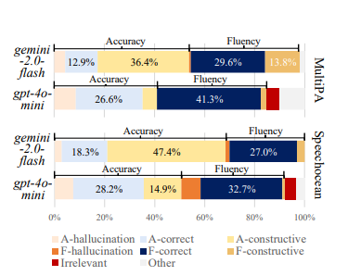
Figure 2.5 TextPA Framework for LLM-Based Feedback (modified from Chen et al., 2025)
What makes this technique so important is the emphasis on learner understanding. Traditional assessment systems approach feedback as a secondary part of the system. LLM-based systems include feedback at the core of the learning process. This is part of a broader change in educational technology away from score-based evaluation toward learner-centered support.
Another advantage of LLM-based feedback systems is their capacity to provide individualized recommendations. Learners differ in their strengths and limitations, therefore generic feedback may not always be beneficial. The LLMs are able to analyze the learner’s responses and make suggestions according to the learner’s performance. This could assist learners focus on particular challenges rather than giving them the same advise as every other student.
Nevertheless, there are still some challenges. One of the most talked about issues is the trustworthiness of the feedback. LLMs provide responses based on the patterns they have learnt from vast datasets, hence the feedback generated may sometimes contain mistakes or misleading information. In educational contexts, incorrect feedback can lead to learner confusion and a reduction in confidence in the system.
Another limitation is consistency. The researchers say that AI-generated feedback might sometimes be inconsistent or offer repetitive suggestions on similar activities. This is especially the case in language acquisition, where pupils would anticipate a consistent and reliable supervision. If feedback differs greatly between tries, it may be hard for learners to evaluate assessment outcomes.
Another difficulty is transparency. Traditional rule-based systems normally offer transparent scoring criteria, but LLM-based systems do not necessarily clarify how recommendations are created. This could be problematic for learners and educators to comprehend the reasons behind some feedback judgments. The lack of transparency is still a key concern in AI backed education.
Comparing the classic automatic feedback systems with the LLM-based alternatives, there are pros and cons for both. Traditional methods tend to produce more predictable and consistent outcomes, while LLM systems allow for more flexibility and customisation. Hence, many experts argue that the best educational systems are those that combine structured evaluation with AI-generated explanations.
Previous studies generally suggest that feedback systems based on LLMs can offer great benefit for language acquisition. They give learners more in-depth explanations, customized recommendations, and ways to develop themselves. But there are still concerns of reliability, consistency and transparency to be tackled. These findings justify the incorporation of AI-generated feedback in the proposed speaking-assessment system and also show the need for thorough evaluation and validation.

2.6 Comparison to Previous Studies
The experiments presented in the previous sections highlight great progresses in voice technologies, pronunciation assessment and AI-based feedback systems. But there are also significant disparities in the emphasis of research, system design and educational goals. Taken together these studies reveal that whereas individual technologies have made major advances, there are few systems providing a full solution for speaking evaluation and learner support.
Most of the research on TTS and STT technologies has focused on enhancing the quality of speech creation and recognition. Studies such as Tan et al. (2021) showed that neural architectures such as Tacotron and WaveNet considerably enhanced the naturalness of speech and recognition performance compared to older techniques. Such technologies form a crucial foundation for language-learning systems, enabling learners to listen to pronunciation models and interact with speech-based applications. The emphasis is on speech processing rather than learner assessment, however. This means that there is little support for the evaluation of speaking performance or personalized learning advice.
On the other hand, pronunciation evaluation studies, such as HiPAMA (Do et al., 2022), have tried to improve assessment accuracy by simultaneously assessing many speech parameters. These systems represent a significant advancement above previous attempts at pronunciation grading because they acknowledge that speaking effectiveness depends on more than one speech attribute. But most pronunciation-assessment models tend to be evaluative and offer limited learner-centered feedback. Learners may be awarded ratings but they are not always provided with thorough explanations on how to improve their performance.
The advent of LLM-based systems provided a distinct perspective. Work such as TextPA (Chen et al., 2025) moved the focus from accuracy of assessment to quality of feedback and learner understanding. Instead of only looking at results, these systems try to explain why learners make mistakes and give individualized recommendations. This practice reveals the increasing awareness of the centrality of feedback in language learning. However, LLM-based systems may confront issues in terms of consistency, transparency and reliability of generated responses.
Research on the use of TTS and ASR in language learning has also revealed opportunities and constraints. According to researchers like Khalid and Muhammad (2014), Kouidri (2025), and Zou et al. (2021), voice technology can make learning more engaging and create possibilities for self-practice. However, these studies also pointed out that the quality of assessment can be affected by faults in voice recognition, variations in pronunciation and non-native accents. Hence, TTS and ASR are useful for language learning, but do not completely address the issues of spoken assessment.
A common characteristic of the examined studies is that most of the systems are limited to a certain component of the learning process. Some studies are devoted to speech generation, some to the assessment of pronunciation, and the most recent ones to the generation of feedback. Each approach offers some useful insights, but relatively few research seek to incorporate these components in one framework. Consequently, learners frequently need to use numerous resources to practice speaking, receive evaluation and get feedback.
Another key discovery is the change in research interests with time. Previous work has mostly focused on improving technical performance like speech quality and recognition accuracy. Recent studies on student experience, personalization of feedback, and educational effectiveness show a growing concern. This shows that effective language learning systems need to balance technical correctness and assistance and usability for learners.
Table 2.1 outlines the main strengths and weaknesses of the studies discussed in this chapter.
Study |  | Main Contribution | Strength | Limitation
Tan et al. (2021) |  | Neural speech synthesis | Natural speech generation | High computational requirements
Do et al. (2022) |  | HiPAMA pronunciation assessment | Multi-feature evaluation | Complex architecture
Chen et al. (2025) |  | TextPA feedback framework | Personalized feedback | Feedback consistency concerns
Khalid & Muhammad (2014) |  | TTS in language learning | Pronunciation modelling | Limited assessment capability
Kouidri (2025) |  | TTS and ASR integration | Immediate feedback | Recognition accuracy issues
Zou et al. (2021) |  | AI speech-learning tools | Increased learner engagement | Does not guarantee learning improvement

Overall, the comparison reveals that present research delivers substantial contributions in various areas of voice technology and language development. However, this still requires a more integrated method to combining speech production, voice recognition, pronunciation evaluation, analytical score prediction, feedback generation and learner progress tracking in one educational system. The proposed AI-based speech assessment system created in this study is based on this gap.

2.7 Gaps in the Literature
As literature review shows that considerable progress has been made in voice technology, pronunciation assessment and AI based educational systems. Researchers have built sophisticated Text-to-Speech and Speech-to-Text technology, refined pronunciation-assessment models, and built Large Language Models that can give personalized feedback. These advances have created new chances to help language learners through automated assessment and intelligent learning systems.
However, there are still some limitations in the current literature. First, many studies focus on one technology and not on the whole learning systems. For instance, TTS research is generally targeted at enhancing speech quality, while pronunciation assessment research is mainly targeted at scoring correctness. For example, many LLM-based systems focus on feedback production but do not include comprehensive speech analysis. Thus, the learners may have acquired an aspect of the learning process, but lack a comprehensive experience in speech assessment.
Second, evaluation results are frequently available without a relevant explanation. Although the pronunciation scores can help to detect the learner’s performance, numerical numbers may not be enough for learning progress. Individual feedback explaining errors and giving learners practical recommendations is usually required. Recent work using large language models has tried to tackle this problem, but research in this field is still in its infancy and needs to be explored further.
Another limitation is related to system integration. Most of the past work addresses speech synthesis, speech recognition, pronunciation assessment and AI-generated feedback individually. Few studies combine these components in a single platform that allows learners to listen to a model pronunciation, record comments, receive evaluation, obtain tailored feedback and track progress over time.
Furthermore, prior research has shown insufficient focus on monitoring learner progress and continuing practice. Many systems monitor individual speaking efforts but do not have capabilities to track performance over multiple sessions. This makes it hard for learners to see improvement and track long-term development patterns.
Finally, questions of dependability of assessment are of importance. Accents, pauses, patterns of hesitation and variances in pronunciation may impair the accuracy of speech-recognition. Therefore, more research is needed to study how speech technology and AI-generated feedback might be integrated to offer more reliable and learner-centred speaking assessment.
To fill these shortcomings, this study proposes an AI-based speaking evaluation system that combines Text-to-Speech, Speech-to-Text, pronunciation analysis, IELTS-style score prediction, AI-generated feedback and learner progress tracking into a unified framework. The suggested method integrates these components to create a more thorough and practical solution for speaking assessment and language learning.

3.Methodology

3.1 Research methodology
This study employed a system-development research approach because the main objective was to design, develop, and evaluate an AI-based speaking assessment system. The study involved software development and data analysis to create a practical application to aid speaking assessment and deliver personalized feedback to learners.
The research was done in several phases. First, a literature review was conducted to understand the state of the art in speech technologies, pronunciation-assessment systems, and AI-based feedback methods. The results of the literature review enabled the identification of research gap and the design of the proposed system.
The second stage was the overall system architecture design. The framework was designed to combine Text-to-Speech (TTS), Speech-to-Text (STT), pronunciation assessment, IELTS-style score prediction, AI feedback, and learner progress tracking into one application.
The development of the application was done after designing it by using Flutter & Dart programming language. Integrate Azure Speech Services for speech recognition and pronunciation assessment. Other AI services were used to generate personalized feedback based on the learner’s performance.
The system was tested with speech responses of more than 30 students after the completion of the implementation phase. Learners engaged with the application through speaking tasks and automated assessment results. The generated scores, transcripts and feedback were analyzed to evaluate the functionality of the system and possible improvements.

Figure 3.1 shows the overall process of the research.
Figure 3.1 The process of research
Review of Literatures
↓
Systems Design
↓
System Development
↓
System Test
↓
Data Analysis
↓
Evaluation and Enhancements
The chosen research design was appropriate in that it allowed for the development of a practical application, and at the same time provided an opportunity to evaluate its performance in a real educational environment.

3.2 Architecture of the System

The proposed system was designed as an integrated AI-based speaking assessment platform that integrates speech technologies, pronunciation analysis, IELTS-style score prediction and AI-generated feedback in a single application. The system is mainly designed to help learners to practice speaking, get the assessment results and customized feedback automatically.
The system is composed of a number of interacting modules that cooperate to analyze learner speech and produce assessment results. The overall architecture of the proposed system is shown in Figure 3.2.
Figure 3.2 Suggested System Architecture
Student feedback
↓
Text-to-Speech (TTS) Component
↓
Sound Recording
↓
Pronunciation Evaluation
↓
Speech-to-Text (STT) Conversion
↓
Feature Selection
↓
Prediction of Scores in IELTS Style
↓
AI Feedback Generation
↓
Dashboard of Results
↓
History & Progress Report
The process starts when a learner chooses a speaking task in the application. The Text-to-Speech module turns the prompt into spoken audio so the learner can hear the model pronunciation before responding. This feature helps to practice pronunciation and to understand how words and sentences should be pronounced.
Having heard the prompt, the learner records a spoken response via the recording module. The recorded speech is then processed by Azure Speech Services for speech recognition and pronunciation assessment. At this stage the system transcribes speech into text and produces scores associated with pronunciation.
In the feature extraction step the transcript and pronunciation results are generated and analyzed. Several speaking characteristics are collected, for example pronunciation, fluency, completeness, prosody, vocabulary, coherence, speech rate and pause frequency. These features provide information on different aspects of learner speaking performance.
After the prediction, the AI feedback module evaluates the learner's performance and provides personalized advice. The feedback is about pronunciation, fluency, usage of vocabulary, grammar and improvement in speaking. The system tries to explain the learners’ strengths and weaknesses in a more understandable way, rather than just showing numerical scores.

Finally, the assessment results are all displayed on the dashboard. Students can view their speaking scores, transcripts, highlighted pronunciation errors and recommendations from AI. It also keeps track of your previous attempts, so you can see your improvement and compare your performance in different speaking sessions.

Together, these modules form a system that provides a complete speaking assessment experience that goes beyond speech recognition, and supports both the assessment and the development of the learner.

3.3 Tools and Development Environment
Several software tools and technologies were used to develop the proposed AI based speaking assessment system, which supports speech processing, user interaction, data analysis and feedback generation. These technologies were selected due to their functionality, reliability and compatibility with the needs of the proposed system.

Most of the application was developed in Flutter. Why Flutter Developers can build modern and responsive user interfaces with a single code base. Moreover, Flutter supports cross-platform development which is great for effective mobile apps’ building.

The app is written on the Dart programming language, which is the main programming language used to develop the Flutter . We chose Dart because it supports Flutter and can create fast and interactive applications.

The speech processing was assisted by the system integration of Azure Speech Services. These services are the conversion of the learner speech into text and the pronunciation assessment. We chose Azure because it has good speech-recognition and pronunciation-analysis features, which are useful for language-learning apps.

For the Text-to-Speech functionality we also used the Azure Speech Services. In this module learners were given the chance to hear the model pronunciation before they recorded their answers. It was introduced to help pronunciation practice and to enhance learners’ understanding of correct speech patterns.

The feedback was produced by the integration of the application with Gemini AI. This component was designed to perform the analysis of the performance of a learner and offer personalized suggestions. Traditional systems mainly give scores, whereas Gemini AI was used to generate more detailed explanations and suggestions related to pronunciation, fluency, grammar and vocabulary improvement.
The system also contained local data storage to store records of learners and their assessment history. This feature enabled users to go through previous attempts, analyze the results, and track their progress. We kept learner history because it provided evidence of changes in performance over multiple speaking sessions.
Table 3.1 presents the main technologies used in the development of the proposed system.
Table 3.1 Development Tools & Technologies
Technology | Purpose
Flutter | User interface and application development
Dart | Application programming language
Azure Speech Services | Speech recognition and pronunciation assessment
Azure Text-to-Speech | Pronunciation modelling and audio generation
Gemini AI | Personalized feedback generation
Local Storage | Saving assessment history and learner records
The combination of these technologies allowed developing a comprehensive AI-based speaking assessment system which can support speaking practice, automated assessment, feedback generation and learner progress tracking in one platform.

3.4 Text to Speech (TTS) Module

The Text-to-Speech (TTS) module was developed to provide pronunciation examples for learners prior to completing speaking tasks. The primary objective of this module is to allow users to hear the proper pronunciation and learn how words and sentences are supposed to sound before they record their responses.
The TTS functionality was created using the Azure Text-to-Speech services. The technology uses AI-generated voices to convert written text into spoken audio. When a learner chooses a speaking activity, the system automatically generates audio from the text prompt shown. The learner can then listen to the pronunciation and begin the speaking activity.
Pronunciation is an important aspect of speaking performance and the TTS module was included. Many language learners have problems with stress, intonation and pronunciation of words. Listening to model speech can help learners to better understand word pronunciation and increase their speaking confidence.
The TTS module also enables the learner to listen to the audio several times. In traditional classroom settings, the pronunciation examples may be given only once; however, the system enables the users to replay the generated speech as many times as they want. This fosters self-directed learning and offers more opportunities to practice pronunciation.
The TTS module is also the first stage of the overall speaking-assessment process. After listening to the audio that has been generated, learners move on to the recording phase and give their spoken answers. In this way the module not only helps with learning pronunciation, but also prepares learners for the assessment process.
To conclude, the Text-to-Speech module is a significant component of the proposed system, as it offers pronunciation assistance, enhances the learner’s comprehension, and creates a more interactive setting for practicing speaking skills.
3.5 Speech to Text and Pronunciation Assessment
A core component of the proposed system is the Speech-to-Text (STT) and pronunciation-assessment module which analyses the learner speech and outputs assessment results. When a learner records a response, the audio is processed through Azure Speech Services, which transcribe the spoken response to text and assess several aspects of speaking performance.
The first function of this module is the speech recognition. The recorded audio is sent to Azure Speech Services where the speech recognition engine translates the spoken response of the learner into text. The transcript is then used for further analysis and to generate feedback. The conversion of speech into text is a necessary step since it allows the system to analyze the content of learner’s responses and to identify possible language problems.
Azure Pronunciation Assessment is used in addition to speech recognition for speech quality assessment of learner speech. The system doesn't produce a single score, but rather several speaking-performance indicators. These indicators offer a more in-depth understanding of learner performance and pinpoint particular areas for improvement.
The pronunciation assessment process looks at four main speech features:
1. Pronunciation – The accuracy with which words are pronounced.
2. Fluency - measures the flow and continuity of the speech.
3. Completeness – how well the learner completes the speaking task.
4. Prosody – assesses the rhythm, stress and intonation of speech.
These scores are automatically generated when the learner finishes a speaking task.
Figure 3.3 Process of speech-to-text and pronunciation scoring
Record learner speech
↓
Speech Recognition with Azure
↓
Generating transcript
↓
Pronunciation Evaluation
↓
Score of pronunciation
FluencyScore .
Completeness Rate
Prosodic score
Many assessment indicators are important, as speaking ability cannot be assessed through pronunciation only. A learner might be able to say words correctly, but struggle with fluency or confidence when speaking. A learner might be able to speak fluently but make pronunciation errors, for example. Thus, the comprehensive evaluation of speaking performance is achieved by considering multiple speech features.
One of the problems with speech recognition is that the learner speech may contain the pauses, hesitations, pronunciation variations and accent variations. These factors can sometimes affect recognition accuracy and quality of transcript. Therefore, caution is needed when interpreting speech-recognition output, especially when analyzing non-native speech.
Despite these challenges, Speech-to-Text and pronunciation assessment integration is the foundation of the speaking-evaluation process. The scores of the generated transcript and speech are used in later stages of the system for feature-extraction and prediction of IELTS-style scores.
Thus, this module is an important component of the proposed application as it transforms the learner speech into measurable data that can be used for assessment, feedback generation and progress monitoring.
3.6 Feature Extraction and Analysis
After the completion of the stages of Speech-to-Text and pronunciation-assessment, the generated results are processed by the feature-extraction and analytical-processing module. The purpose of this stage is to collect and structure information from learners’ speech to be used for assessment and to generate feedback.
The system then extracts multiple features from the results of pronunciation assessment and the generated transcript. These features capture different aspects of the speaking performance. They are then used to estimate the overall speaking level of the learner.
The features extracted are:
1. Pronunciation score
2. Rate of fluency
3. Completeness score
4. Prosody score
5. Use of vocabulary
6. Consistency of answers
7. Rate of speech
8. Pause rate
9. Transcript
The first four features are directly generated from Azure Pronunciation Assessment. These indicators provide quantitative information on quality of learner speech and pronunciation performance.
The speech scores and the generated transcript are exploited to extract language related features. The system analyzes vocabulary, sentence structure and the organization of ideas. This information provides a wider perspective on speaking performance than just based on pronunciation scores.
Figure 3.4 Extraction of features and analytical processing
Pronunciation Grade
Fluency Score.
Completeness Rate
Prosody Scoring
Transcript
↓
Feature Selection
↓
Analytical Processing
↓
IELTS Score Prediction in IELTS Style
The analytical-processing stage integrates the extracted features and prepares them to make a prediction at the speaking level. The system does not evaluate one feature but multiple aspects of the learner’s performance simultaneously. This approach was chosen because speaking ability is determined by a number of interrelated factors, not just one isolated measure.
For example, one learner may have good pronunciation but poor fluency. Another learner may have good fluency but poor vocabulary. Combining several features will provide a more balanced assessment of speaking performance.
Extracted information is also used for feedback generation. By identifying strengths and weaknesses across different features, the system can make more personalized recommendations and suggest improvements.
The feature-extraction and analytical-processing stage serves as a bridge between speech analysis and final assessment. It converts raw speech data into structured data that can be used for IELTS-style prediction, learner feedback and progress monitoring.

3.7 Predicting the Score in IELTS Style

The main goal at this stage is to generate a prediction of IELTS style speaking from learner speech performance. Unlike traditional machine learning approaches that require large labelled datasets and model training, the proposed system does not use a separately trained machine learning model. It does not simply report results from speech assessment, transcript analysis and analytical processing, but combines these to estimate overall speaking performance.
After feature extraction, the system is fed a set of evaluation metrics like pronunciation, fluency, completeness and prosody scores computed by Azure Pronunciation Assessment. Also, the evaluation considers information from the transcript, such as vocabulary use, organization of responses and the quality of the language.
These features are combined to provide an overall estimate of the learner’s speaking ability. The system uses an analytical scoring approach in which several speaking characteristics are combined rather than one single score. That’s how speaking ability is scored in real language tests, where performance is a function of many factors working together.

Figure 3.5 IELTS Style Score Prediction Process
Pronunciation Sign
Fluency Score.
Completeness Rate
Prosody Rating
Analysis of Transcript
↓
Analytical Processing
↓
Speaking Assessment Overall
↓
Prediction in IELTS Style
The predicted score produced is intended to provide learners with an approximate indication of their speaking level and not an official examination result. The prediction is used to help learners to understand their current performance and to identify areas that need to be further improved.
A major advantage of this approach is that it does not require large training datasets or complicated model development procedures. Instead, it uses assessment information already generated by speech processing technologies, together with transcript analysis to generate meaningful evaluation results.
However, as the prediction is based on analytical processing, not the official IELTS assessment procedures, the results should be regarded as supportive learning information rather than official certification results. Therefore, the system was validated by comparing the predictions generated against human judgement and the reliability of the proposed approach was evaluated.
A critical part of the system is the IELTS-style score-prediction module, which converts the outputs of speech analysis into a format that is easy for learners to understand and use to monitor their speaking progression.

3.8 AI-generated feedback

The AI Feedback Generation module aims to generate personalized feedback for learners according to their speaking performance. Numerical scores do show levels of performance, but they do not always tell us why a learner got a certain result or how to improve. So, this module was added to give more meaningful and learner friendly feedback.
The feedback-generation process uses the assessment results and transcript produced in the previous stages of the system. Based on the analysis of information such as pronunciation scores, fluency scores, completeness, prosody, and transcript content, strengths and weaknesses of the learner are evaluated. This information is then passed to Gemini AI which then creates personalized feedback and suggestions for improvement.
Figure 3.6 Process of AI feedback generation
Assessment Results
↓
A Transcript Analysis
↓
Gemini AI Processing
↓
Personalized Feedback
↓
Suggestions for Students
The feedback provided is on some aspects of speaking performance such as pronunciation, fluency, vocabulary use, grammar accuracy and organization of the response. The system does not just give scores, it explains the performance of the learner in plain language and gives practical recommendations for improvement.
For example, if a learner is very fluent but struggles with pronunciation, the system could suggest more practice in pronunciation but acknowledge fluency as a strong point. Similarly, if there are frequent pauses in speaking, the feedback could motivate learners to speak more fluently and with more confidence.
One of the main advantages of AI-generated feedback is its personalization. Different learners have different strengths and weaknesses, and the system can give recommendations to match individual performance. This approach provides more useful learning support than generic feedback messages that are the same for all users.
But there are some limitations of AI-generated feedback. The quality of the recommendations is dependent on the quality of the assessment data and transcript generated by the earlier stages of the system. Some of the feedback suggestions may be less reliable if speech recognition is not accurate. Also, sometimes AI-generated responses may repeat similar recommendations in multiple speaking attempts.
The AI feedback module, despite these limitations, plays an important role in the proposed system as it assists learners to understand their performance and to identify areas that require further development. The system provides more supportive and interactive learning experience than traditional score-based approaches by integrating assessment results and personalized recommendations.
In conclusion, the AI Feedback Generation module enhances the educational value of the application by converting the assessment results into actionable feedback that learners can apply to improve their speaking skills.

3.9. System Validation

System validation was performed to assess the reliability of the proposed AI-based speaking assessment system and to investigate if the generated IELTS-style predictions were reasonable. Since the system was designed to support speaking practice and assessment, it was important to look at how the generated results compared with human judgment.
The speech responses from more than 30 students were adopted to evaluate the application. Learners took part in speaking tasks during testing and were provided with automated assessment results comprising pronunciation scores, fluency scores, transcript analysis, IELTS-style predictions and AI-generated feedback.
A subset of learner responses was reviewed manually to evaluate reliability of the generated predictions. The analysis of speaking recordings and transcripts was based on speaking assessment criteria such as pronunciation, fluency, use of vocabulary, and coherence. The manually reviewed performance was then compared to the system predictions.
Figure 3.7 System Validation Processes
Student Speaking Answers
↓
Automated evaluation
↓
IELTS prediction
↓
Manual examination
↓
Results Comparison
Comparison showed that the predictions generated by the system were generally consistent with the overall speaking performance observed during the manual review. Learners who had better pronunciation, fluency and coherence were more likely to be given higher predicted IELTS-style scores, whereas learners who had pronunciation problems and frequent pauses were more likely to be given lower predictions.
The validation process was not meant to substitute the official IELTS testing procedures, but to see if the system could produce reasonable and meaningful evaluation results. Therefore, we propose to treat the generated predictions as rough indicators of speaking performance, not official examination scores.
There are some limitations to be acknowledged too. The validation process was performed with a relatively small sample size and was carried out in an educational context, not within a formal examination setting. In addition, the speaking assessment is intrinsically subjective, which can impact the manual assessment.
Despite these limitations, the validation process yielded useful evidence that the proposed system could generate assessment results that generally corresponded to learner speaking performance. The results also helped to identify areas for improvement and further refinement of the application during testing.
Student Human Rating System Prediction
Student | Human Rating | System Prediction
S1 | 7.0 | 7.0
S2 | 5.5 | 5.0
S3 | 4.5 | 4.0
S4 | 6.0 | 6.0
S5 | 7.5 | 8.0
Table.3.2
Comparison between manual evaluation and system predictions shows a generally high degree of agreement. In some cases small differences were observed but the predicted IELTS-style bands were generally within 0.5 band points of the human assessment. This suggests that the proposed framework was able to produce reasonable and consistent speaking level estimates.
Overall, system validation was an important part of the assessment of the proposed framework’s reliability and the meaningful support for learner speaking practice that the generated IELTS-style predictions provided.

3.10 Ethical Considerations

Ethical considerations were given in the entire process of development and testing of the proposed AI-based speaking assessment system. Given that this study involved the collection and analysis of student speech recordings, it was important to ensure that participant data was handled responsibly and used only for academic purposes.
The testing was not mandatory. Students were informed about the aim of the study and the use of their speech samples. Participants were also told that the data collected would only be used for system evaluation and research purposes.
The analysis was performed and the dissertation written up without personal information to protect the privacy of participants. The study focused on speaking performance and system functionality, not on individual identities. The assessment results and recordings were kept confidential and were used only for the research process.
The use of Artificial Intelligence for assessment and feedback generation was a big ethical question. The system was designed to provide supportive learning feedback, not formal examination results. Thus, the generated IELTS-style predictions should be considered as approximate indicators of speaking performance, rather than as formal language-certification scores.
The system was also developed with fairness and reliability in mind. Because speech-recognition technologies are sensitive to differences in pronunciation, accent and manner of speaking, the results produced by the system were interpreted with caution. The application was designed to improve learner development rather than replace human teachers or professional examiners.
The research and development process was conducted following ethical principles of privacy, voluntary participation, confidentiality, and responsible use of AI technologies.

4.Results

4.1 Results of system tests

The system was used to test the functionality of the proposed AI-based speaking assessment system and its ability to analyze the learner speaking performance. During the testing process, more than 30 students were using the application to perform the speaking tasks and to get the results of the automated assessment.
During the testing, the participants recorded their responses with the application. The audio recordings were processed using Azure Speech Services to generate transcripts and pronunciation-assessment scores. The system then processed the extracted speech features to deliver IELTS-style predictions with AI-generated feedback.
Test results were positive for all key components of the system. The Text-to-Speech module produced examples of pronunciation, the Speech-to-Text module transformed learner speech into text, and the pronunciation-assessment module produced indicators of speaking performance. The system was also able to generate personalized feedback and save the learner results in the application.
During the testing, a number of different types of output were produced, including scores for pronunciation, fluency, completeness and prosody, IELTS style predictions, transcripts and feedback reports. These outputs provided detailed information on learner speaking performance and allowed users to identify areas for improvement.

Figures 4.1-4.2 show some of the outputs produced by the system during testing.
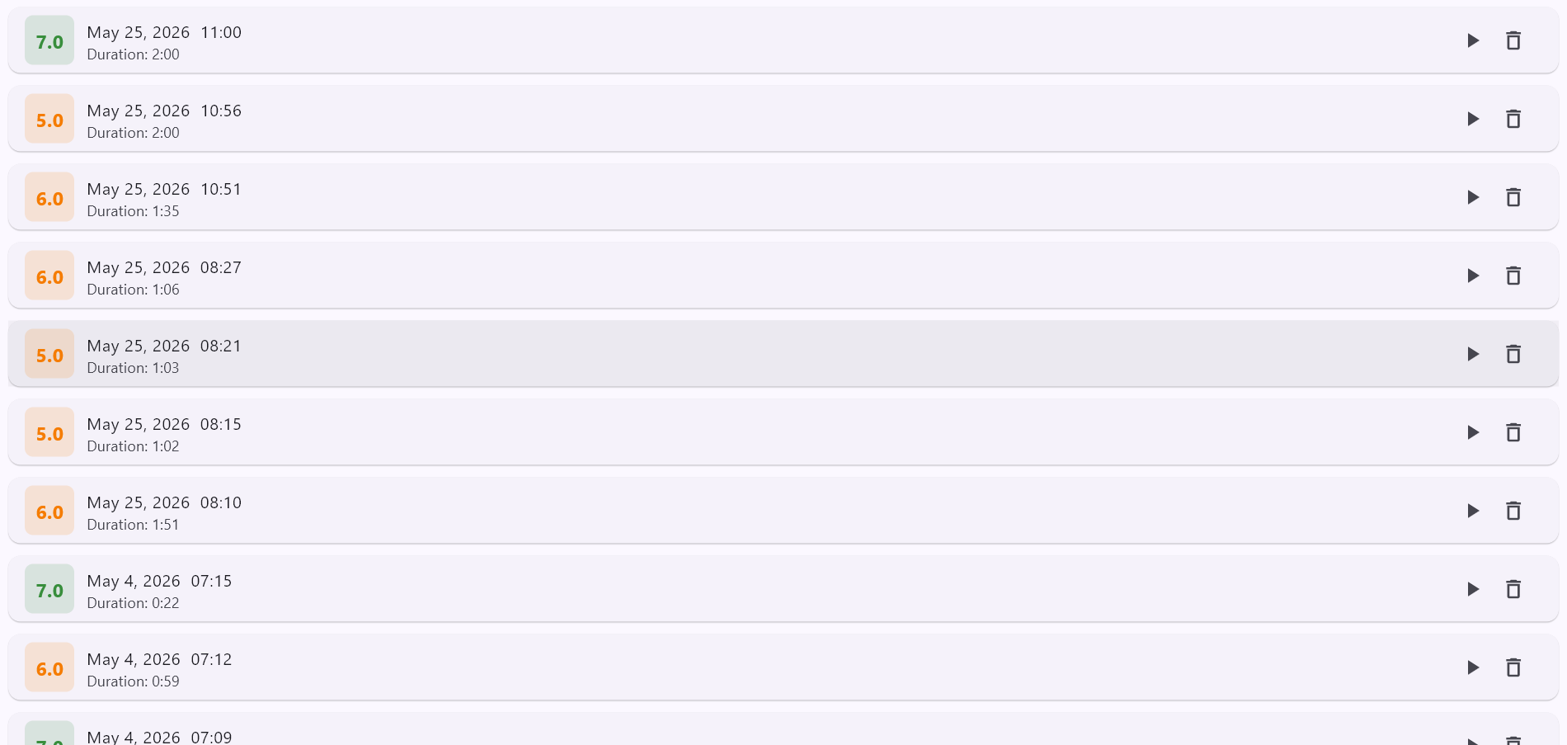
Figure 4.1
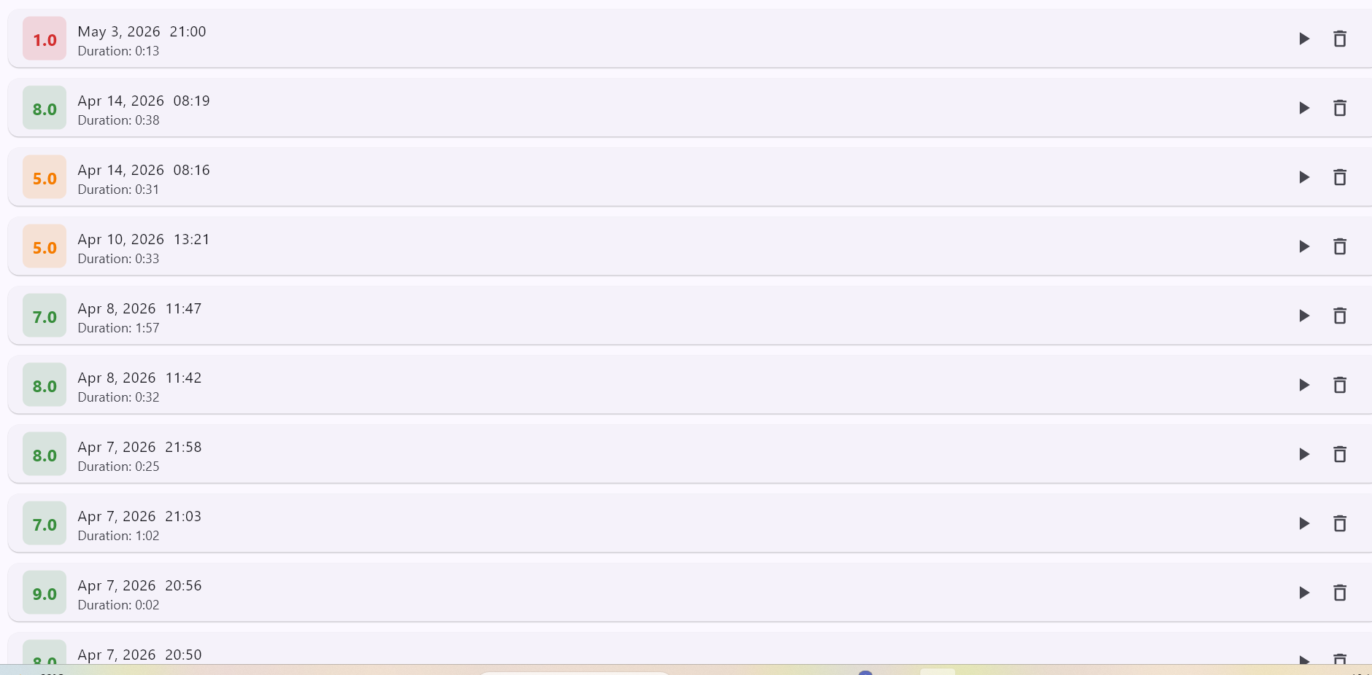
Figure 4.2
The tests showed that the proposed system can integrate speech technologies and AI-based feedback on a single platform. The results provided immediate assessment and personalized recommendations to the learners, which supported the speaking evaluation and independent learning.
4.2 Speaking assessment results
The system’s speaking assessment results provided detailed information on learner performance on a number of speaking features. These included pronunciation, fluency, completeness, prosody and overall IELTS-style predictions. The system could assess speech from a broader perspective, considering various aspects of speech, rather than relying on a single score.
The results showed a great deal of variation among the participants, because of their differences in speaking ability and English language proficiency. Some learners had better scores in pronunciation and fluency, others had problems with pauses, pronunciation accuracy or speech organization. This variation was expected, because the participants were at different levels of speaking experience.
Scores of pronunciation were generally a reflection of how accurately learners said spoken words. Students who pronounced more clearly and who made fewer pronunciation errors tended to get higher scores. On the other hand, those who struggled to pronounce words tended to have lower scores. This would indicate that pronunciation was still one of the most influential elements affecting the overall speaking performance.
The fluency scores were used to assess the flow and continuity of the speech. Generally, higher fluency scores were given to learners who had less interruptions and less hesitations. Frequent pauses and hesitation patterns were often associated with lower performance in fluency. This finding underscores the significance of speaking confidence and continuous speech production in speaking activities.
Completeness scores measured how well learners responded to speaking tasks. A higher score for completeness was generally assigned to participants who gave more elaborate and longer answers. Learners who gave short or incomplete answers generally scored lower, as the system had less information to evaluate.
Prosody scores evaluated speech rhythm, stress, and intonation. Some learners showed natural speaking style and some had problems to keep appropriate rhythm and intonation during their responses. These differences affected the overall evaluation and contributed to differences in speaking performance.
The predictions produced in the IELTS style were at different levels of performance and reflected the combined effect of the speech features that were assessed. Learners who performed better in terms of pronunciation, fluency and response quality generally received higher predicted bands, whereas learners who struggled in these areas were likely to receive lower predicted bands.
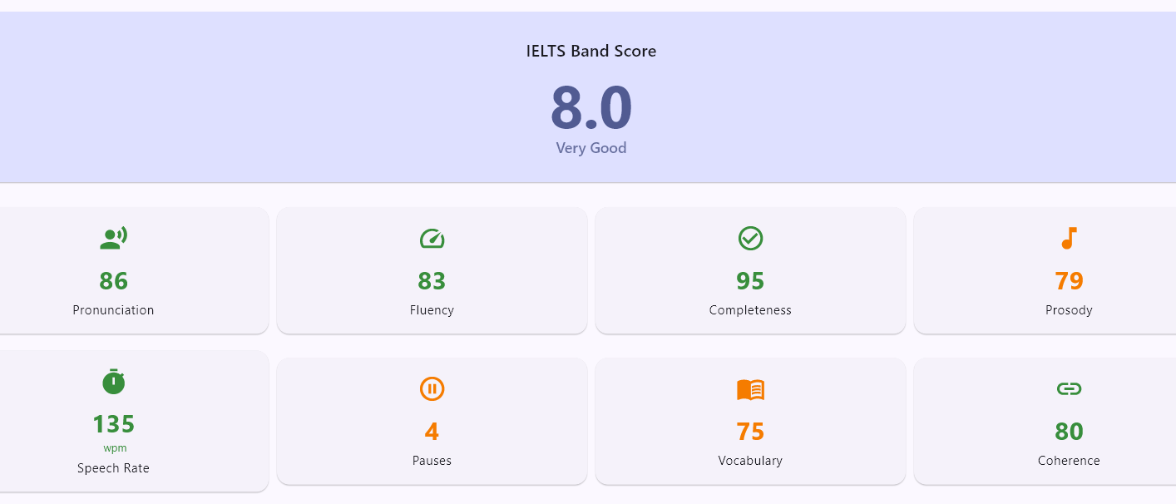
Figure. 4.3.
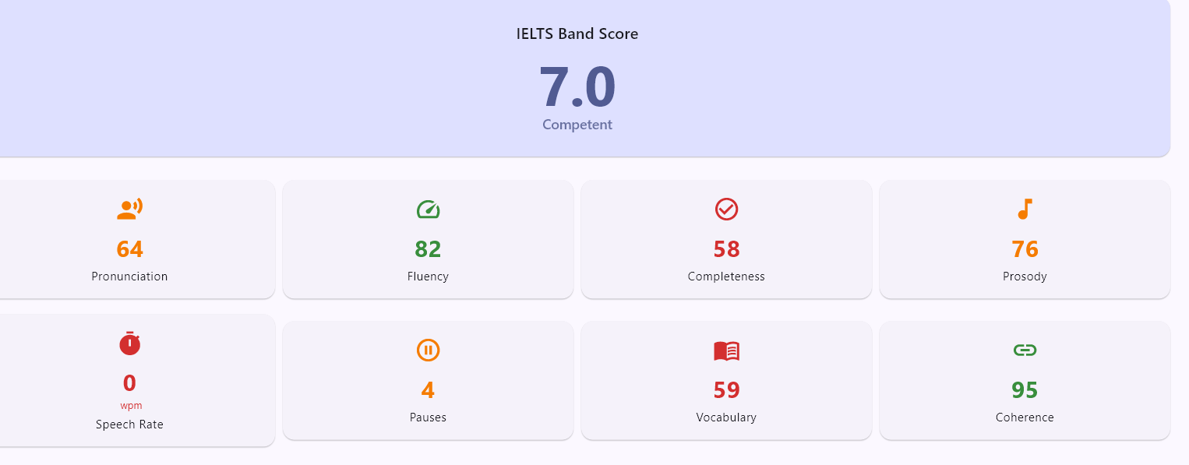
Figure 4.4
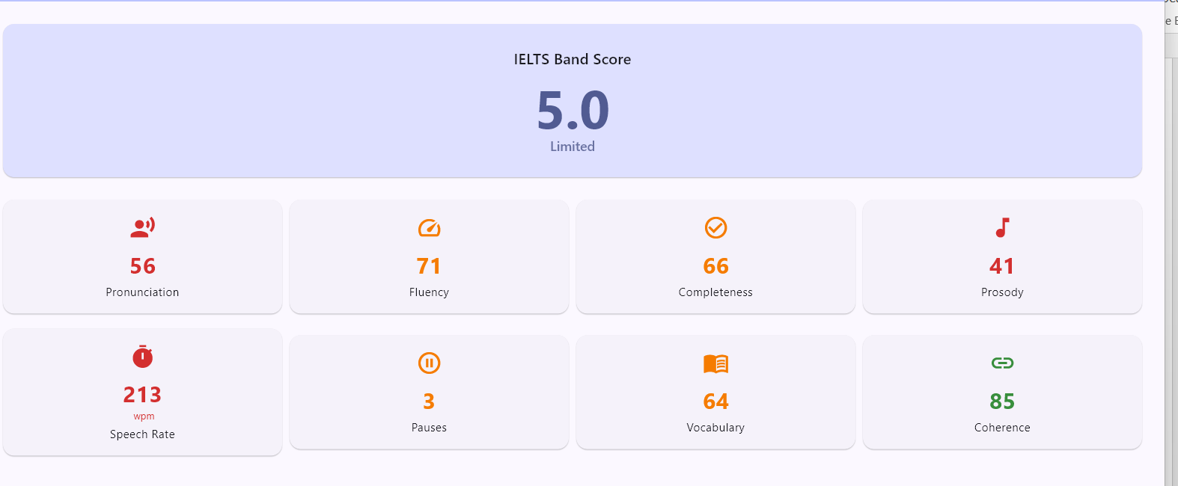4.5. Figure 4.5
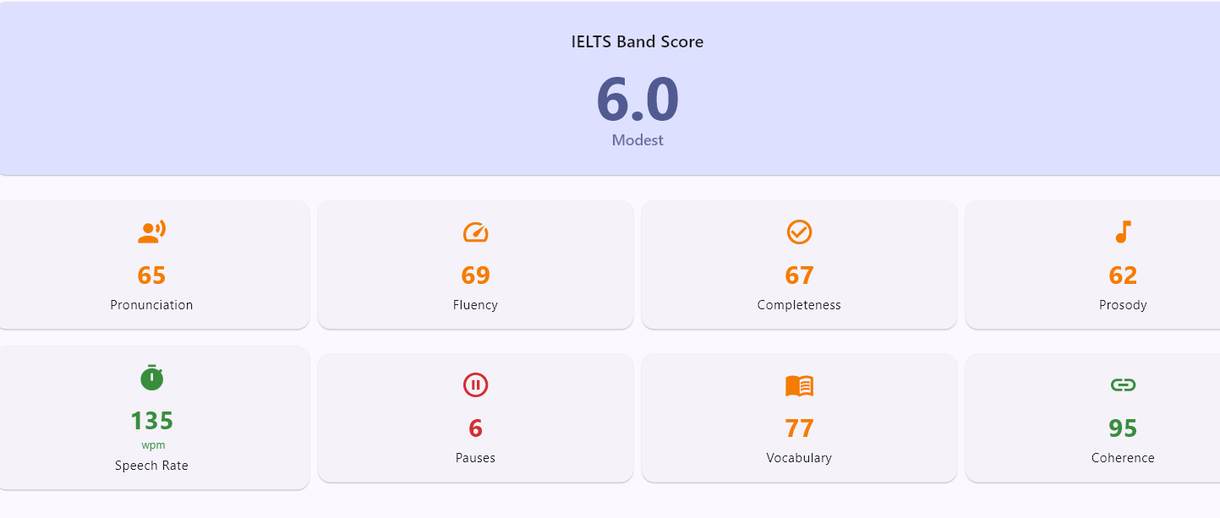
Figure 4.6
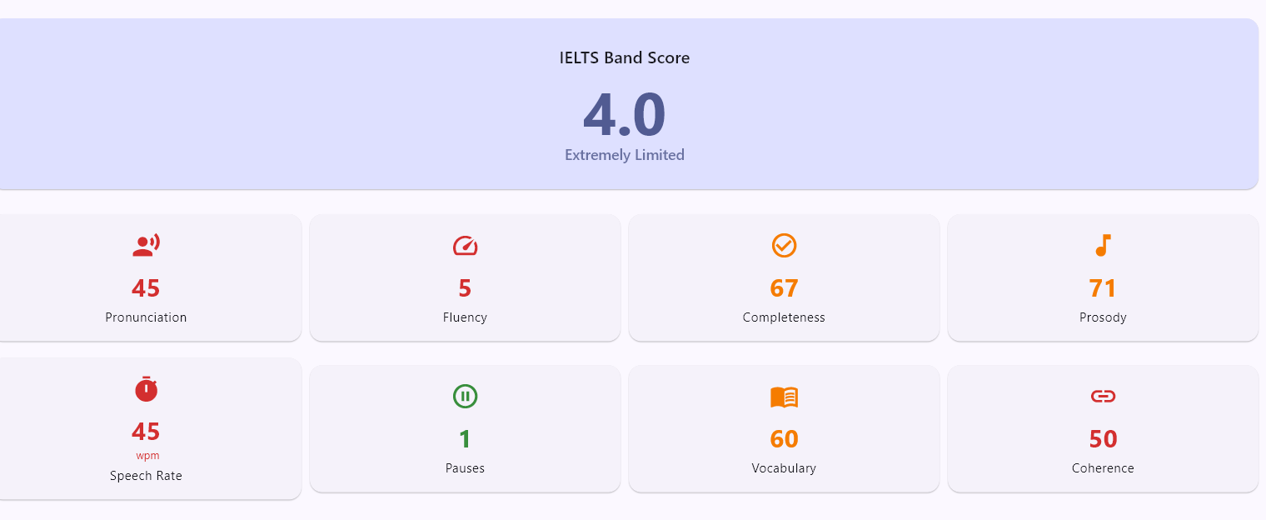
Figure 4.7

Figures 4.3–4.7 and Table 4.1 present five representative student results to illustrate the range of assessment outcomes generated by the system.
Student | IELTS Band | Pronunciation | Fluency | Completeness | Prosody | Vocabulary | Coherence
S1 | 7.0 | 64 | 82 | 58 | 76 | 59 | 95
S2 | 5.0 | 50 | 58 | 63 | 36 | 69 | 90
S3 | 4.0 | 45 | 50 | 67 | 71 | 60 | 50
S4 | 6.0 | 67 | 70 | 79 | 58 | 70 | 90
S5 | 8.0 | 86 | 83 | 95 | 79 | 75 | 80

Table 4.1 Typical Results of Speaking Assessment from System Testing
Fig. 4.3-4.7 are representative assessment results generated during system testing. The results of the samples demonstrate a clear variation of learner speaking performance in different assessment categories. Predicted IELTS bands ranged from 4.0 to 8.0, demonstrating that the system could distinguish between different levels of speaking ability. Learners with higher scores on pronunciation, fluency and completeness tended to receive higher IELTS-style predictions. For example, Student 5 has the highest predicted band score 8.0 and performed well in most of the speaking indicators such as pronunciation (86), fluency (83) and completeness (95). In comparison, Student 3 had a predicted band score of 4.0 with lower scores in pronunciation, fluency, and coherence. These results indicate that the generated IELTS-style predictions were consistent with the overall speaking characteristics identified by the system. The results also demonstrate that pronunciation and fluency were some of the most powerful factors affecting speaking performance, while coherence tended to be relatively strong across most participants. In summary, the results of sample assessment show the capability of the proposed system to analyze learner speech and generate differentiated evaluating results according to the multiple speaking features. The results show that the system was able to produce different assessment results according to the levels of learner performance and to generate detailed information about the strengths and weaknesses of individual speaking skills. We present here only five representative results, but the system was tested with more than 30 student responses. The wider testing process produced a range of IELTS style predictions, indicating the system’s ability to assess learners with a range of speaking ability.

4.3 Results of Transcript Analysis

Besides the ability of generating the speaking score, the proposed system also conducted transcript analysis to provide learners a more detailed understanding of their speaking performance. The recorded speech was transcribed into text and presented in the application after each speaking task. Learners could then go back to their responses and see where they might have problems with pronunciation and speaking.
One of the key features of the transcript-analysis module was the colour-coded highlighting. Words that were pronounced correctly were highlighted in green, and words that had pronunciation problems were highlighted in orange or red. This visually helped learners to quickly identify certain sections of their speech that needed improvement.
Results of the transcript analysis showed that the pronunciation difficulties were not evenly distributed across responses. Some learners had only a few highlighted words indicating relatively strong pronunciation performance, while others had a larger number of pronunciation issues across their responses. These differences were a reflection of differences in the speaking ability of the participants.
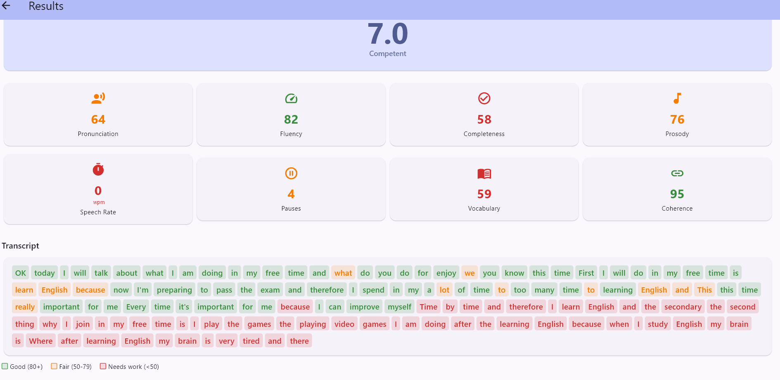
Figure 4.8 Sample Transcript Analysis

The transcript-analysis feature offered a range of educational advantages. First, it provided learners with specific feedback about pronunciation problems rather than a numerical score. Second, it enabled learners to relate the results of their assessment to particular words and phrases in their responses. Finally, it encouraged self-reflection, making learners to reflect more on their speaking performance.
During testing, it was found that the quality of the transcript was very dependent on the accuracy of the speech recognition. Clear and fluid speech tended to produce more accurate transcripts, whereas speech with frequent pauses, hesitations, or pronunciation errors occasionally resulted in recognition inaccuracies. Nonetheless, the generated transcripts were useful for the identification of general speaking patterns and areas for improvement.
The results of the transcript analysis also provided support to the AI feedback module by giving more information about the learner responses. The generated transcripts were leveraged to identify vocabulary usage, response organization and language patterns. This aided in the personalized recommendations generated by the system.
Overall, the transcript-analysis function improved the assessment process by offering detailed visual feedback to learners and assisting them to better understand the strengths and weaknesses of their speaking performance.

4.4 Results of AI Feedback
One of the key elements of the proposed system was the AI feedback module, designed to provide learners with personalized recommendations based on their speaking performance. Traditional assessment systems mainly generate scores as numbers, while the AI feedback module attempted to generate explanations of learner strengths and weaknesses, and areas of improvement.
Following each speaking task, the system analyzed assessment scores and transcript information and generated feedback through Gemini AI. The produced feedback covered pronunciation, fluency, usage of vocabulary, grammar accuracy and general speaking performance. This enabled learners to receive more detailed guidance than simple score-based evaluation.

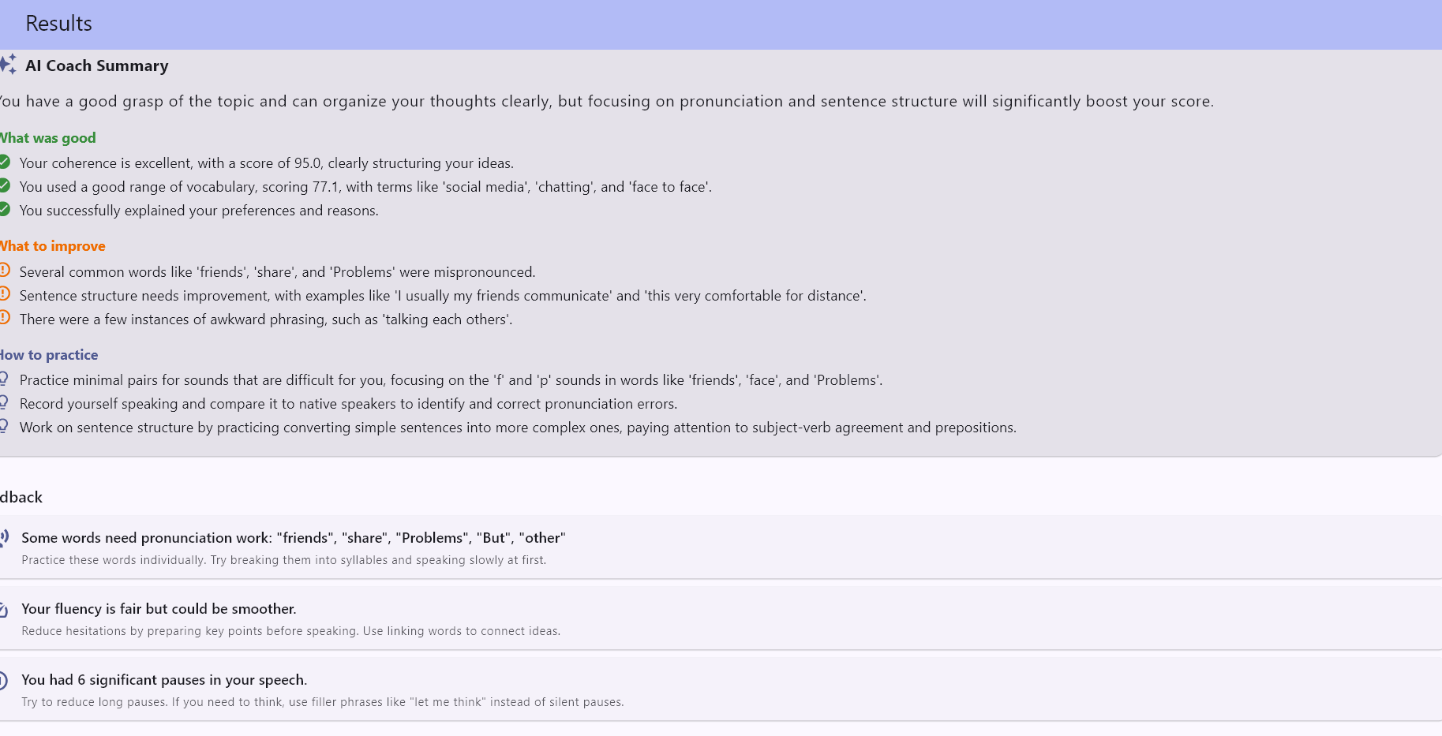
Figure 4.9 Example of AI feedback

The feedback was given depended on the learner's performance. Students who performed better in speaking tended to receive positive comments on their strengths while learners who did poorly were advised to practice more. For example, learners whose pronunciation scores were low were encouraged to work on pronunciation exercises, while learners with many pauses were given suggestions about fluency development and speaking confidence.
The AI feedback was also accompanied by explanations rather than only highlighting errors. This was especially helpful, as it helped learners to have a better understanding of why their speaking performance in certain areas needed to be improved. Instead of simply stating that the students did poorly, the system attempted to provide practical suggestions on how to learn better in the future.
During testing, the feedback was found to make assessment results easier to understand. Learners were able to connect their scores to specific recommendations and pinpoint areas for further development. This led to a more learner-centric assessment experience than traditional score-only systems.
However, some limitations were found too. Since the feedback was based on transcript quality and assessment outcomes, occasional inaccuracies from the speech recognition may have affected the generated recommendations. In addition, a few responses to the feedback contained similar suggestions for different speaking attempts. However, despite these constraints, the feedback continued to be valuable in promoting learner reflection and self-enhancement.
Generally, the AI feedback module contributed significant educational value to the proposed system by converting the assessment results into comprehensible recommendations. The feedback generated helped learners to know how they performed and guided them for future speaking practice.

4.5 System Changes and Enhancements

During testing, an important issue was identified in the assessment process. At first, the system could give speaking scores and predictions in the IELTS style even when learners spoke for a few seconds. The application was able to generate outputs, but these were often unreliable because there was not enough speech data to evaluate very short responses in a meaningful way.
This was evident in instances where some students recorded short answers and still got scores for assessment. The generated results showed that the system could not accurately evaluate critical speaking features such as fluency, pronunciation, coherence, and speaking quality when the recording duration was too short after review.
To overcome this limitation, the system was modified by including a minimum speaking time. The application asked the learners to speak at least for one minute before generating assessment results. The aim of this modification was to have enough speech data for analysis and evaluation.
Figure 4.10-4.11 Implementation of Minimum Speaking Duration Requirement

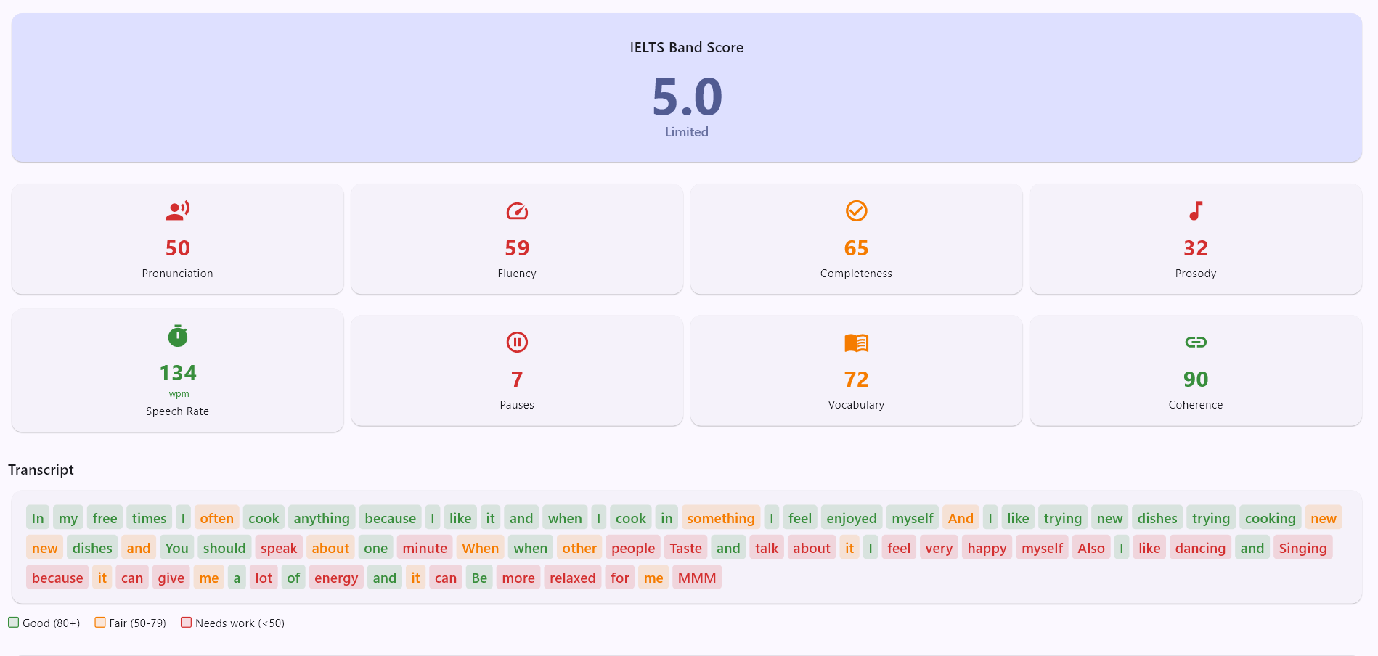
Figure 4.10
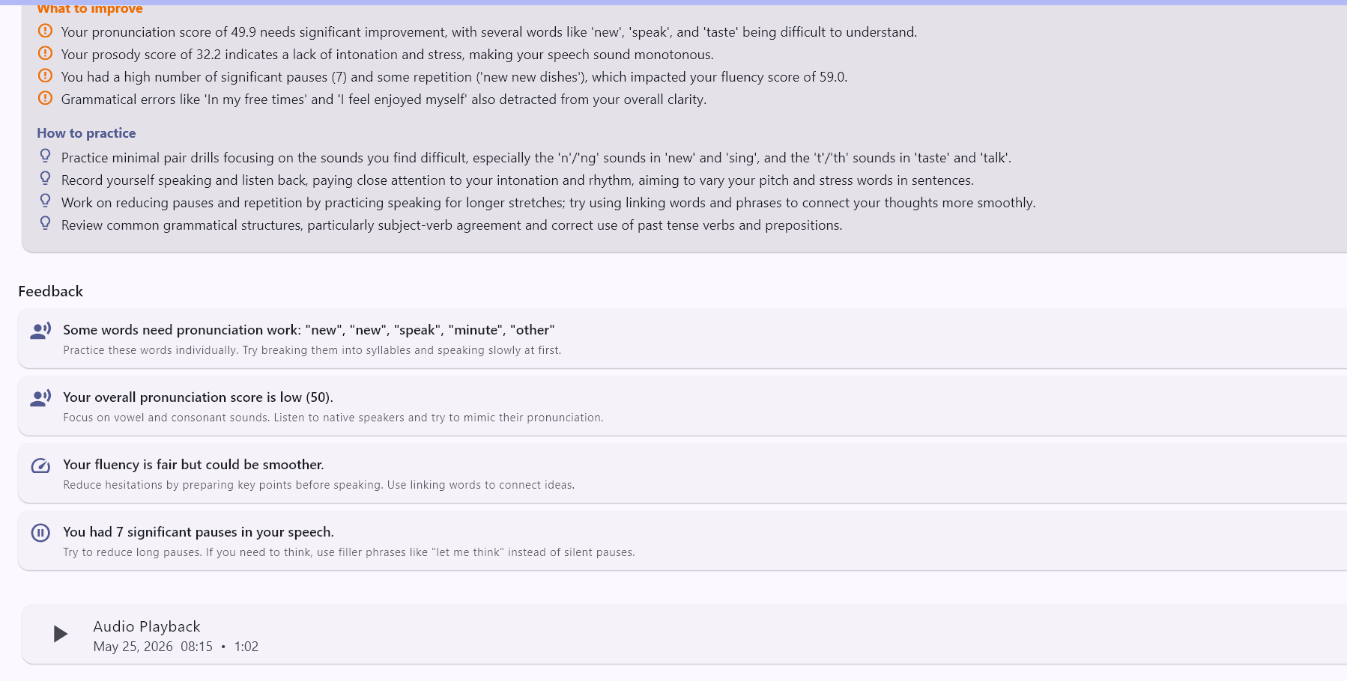
Figure 4.11

Following this change, the quality and consistency of assessment results improved. Longer responses provided more information for speech analysis making the system to produce more reliable scores for pronunciation, transcripts, IELTS prediction and AI feedbacks.
The one-minute requirement also resulted in an increased educational value of the system. Learners were encouraged to provide fuller responses that would enable them to better demonstrate their speaking ability. As a result, the generated feedback was more meaningful and more similar to real speaking performance.
This change shows how useful practical testing is for developing the system. In the original design, it was possible to evaluate any speech recording. Tests showed that additional controls were required to improve the reliability of the results. So the 1-minute speaking requirement was an important addition to the proposed framework and helped the overall effectiveness of the system.

5.Discussion

5.1 Findings Discussion

Chapter 4 shows the results that the proposed AI-based speaking assessment system was able to combine multiple technologies into one learning platform. The application was successful in integrating Text-to-Speech, Speech-to-Text, pronunciation assessment, IELTS-style score prediction and AI-generated feedback, to facilitate speaking practice and assessment of learners.
A major finding of this study is that the combination of different speech-analysis components allowed a more complete assessment of speaking performance than a single assessment indicator. The scores generated for pronunciation, fluency, completeness and prosody allow the system to assess several aspects of the learner speech at the same time. This is consistent with the findings of Do, Kim and Lee (2022), who argued that speaking assessment should take multiple speech characteristics into account rather than isolated pronunciation measures.
The results of the transcript analysis also showed the benefits of visual feedback for speaking assessment. The system allowed the user to pinpoint which parts of the learner responses were problematic in terms of pronunciation. This finding is in line with previous studies that suggest detailed and comprehensible feedback may promote learner awareness more effectively than numerical scores alone.
Another important result concerns the AI feedback module. The generated recommendations were not only assessment results but also explanations and practical suggestions to the learners. This bolsters the increasing focus on learner-centered feedback referred to by Chen et al. (2025). Traditional automated systems mainly focus on scoring, while the proposed system tried to help learners understand why they performed as they did and what possible ways they could improve their performance.
The results also showed that assessment reliability was important. During the testing it was observed that very short responses could lead to unreliable assessment outcomes. The addition of a one minute speaking requirement increased the quality of generated predictions and feedback by providing enough speech data for analysis. The result underscores the importance of real-world testing and system improvement in the development of educational software.
Overall, the results suggest that the integration of speech technologies and AI-generated feedback can support automated speaking assessment and provide learners with useful information about their speaking performance. While not intended to replace human assessment, this system shows the promise of AI-based technologies to support language learning and independent speaking practice.

5.2 Comparisons with Previous Studies

The findings of this study are generally consistent with prior research on speech technologies, pronunciation evaluation, and AI-assisted language learning. Like the studies reviewed in Chapter 2, the proposed system showed that speech technologies can be effectively used to support speaking practice and automated assessment.
The incorporation of Text-to-Speech and Speech-to-Text technologies in the proposed system is consistent with the findings of Tan et al. (2021) who pointed out the importance of modern speech technologies in designing more interactive and realistic language-learning environments. In the present study, these technologies were successfully applied to support both pronunciation modelling and speech analysis, allowing learners to conduct speaking activities within one platform.
The results also corroborate the work of Do, Kim and Lee (2022) who argued that speaking assessment should take into account multiple speech features instead of a single pronunciation score. The proposed system assessed the performance of the learner based on some indicators such as pronunciation, fluency, completeness and prosody, akin to the HiPAMA framework. The results showed that multiple feature analyze provided a more balanced view of speaking performance.
Moreover, the study is similar to the TextPA framework proposed by Chen et al. (2025). Both systems extend traditional score-based assessment with explanatory feedback and learner support. But TextPA was mainly about feedback on pronunciation, while the proposed system was trying to put assessment, IELTS-style prediction, transcript analysis, and progress tracking into one application. The main contribution of the study lies in the wider integration.
The results are also in line with previous studies on TTS and ASR technologies in language learning. According to studies conducted by Khalid and Muhammad (2014), Kouidri (2025), and Zou et al. (2021), speech technologies can lead to the improvement of learner engagement and opportunities for independent practice. Similar observations were made in system testing where learners could complete speaking activities, receive immediate results and review their performance without direct teacher involvement.
Despite these similarities, the present study also identified challenges that have been reported in previous research. Pronunciation differences, pauses and differences in speaking style still impacted speech recognition accuracy. This result confirms earlier findings indicating the difficulties of automated speech analysis for non-native learner speech.
Overall, the results of this study support much of the existing literature and extend prior work through the integration of multiple technologies in a single educational platform. The results indicate that the integration of speech technologies, analytical assessment and AI-generated feedback is able to provide a more comprehensive speaking-assessment environment than systems focusing on one component of the learning process only.

5.3 Advantages of Proposed System

During the development and testing of the proposed AI-based speaking assessment system, several strengths were identified. One of its greatest strengths is the integration of multiple technologies in a single platform. Most existing systems focus on only one aspect of language learning, whereas the proposed application integrates Text-to-Speech, Speech-to-Text, pronunciation assessment, the prediction of IELTS-style scores, transcript analysis, and AI-generated feedback. This integration offers learners a more holistic speaking-assessment experience.
Another advantage is that the system gives results immediately. Assessment scores, transcript analysis and personalized feedback are provided to the learners in a short period of time after a speaking task. This enables users to identify strengths and weaknesses without waiting for a manual review.
The transcript-analysis feature also is a significant benefit. The system highlights pronunciation challenges in learner responses, enabling users to identify specific words and phrases to practice. This makes the assessment process more understandable and supports self-reflection.
Moreover, the AI feedback module contributes further educational value to the system. The app provides feedback on your pronunciation, fluency, grammar, vocabulary and speaking performance instead of just a numerical score. Feedback is provided to learners on their results and they are given practical recommendations for further progress.
Another strength is that it includes progress tracking and learner history. The app saves the results of previous assessments so users can look back at previous performance and see the development over time. This feature encourages continued practice and independent learning.
Finally, the system was designed for accessibility and usability. The user interface was designed to be simple and easy to use. It was designed to enable the learners to complete speaking activities without requiring advanced technical knowledge. This makes the application suitable for a broad spectrum of users.
In summary, the proposed system successfully integrates the assessment and feedback functions into one learning environment, and provides a useful tool for learners to practice speaking and improve themselves.

5.4 Problems and Difficulties

The development and testing of the proposed AI-based speaking assessment system was faced with many challenges and difficulties. Challenges included speech recognition, assessment reliability, AI-generated feedback and integration of the system.
Accuracy of speech recognition was one of the biggest challenges. Recognition accuracy was generally good for Azure Speech Services, but there were instances when it dropped when learners spoke unclearly, made many pauses, or used non-standard pronunciation. The quality of the transcript was affected by occasional pronunciation errors, which could affect later stages of analysis and development of feedback.
A further challenge was the learners’ different styles of speaking. The participants had different levels of English proficiency, speaking speed and pronunciation. The system had to deal with a wide variety of speech patterns. This sometimes posed challenges for consistently evaluating responses across different learners.
One significant issue identified during testing was very short speaking responses. At first, the system made predictions similar to IELTS even if the learners spoke only for a few seconds. The application was capable of producing scores, but the results were often unreliable because there wasn't enough speech data to properly analyze. To resolve this, we added a minimum speaking time of one minute before the assessment results could be generated.
The AI feedback module had its own problems too. Gemini AI was capable of providing personalized recommendations but there were some responses with similar recommendations across different speaking attempts. Moreover, the quality of the generated feedback depended on the accuracy of the transcript and assessment results of previous stages of the system.
Another challenge was to integrate multiple technologies into one application. The system was developed using Flutter, Azure Speech Services, pronunciation assessment tools, and Gemini AI. During development, the system was thoroughly tested and debugged to ensure seamless communication between the components.
The research was also challenged by time constraints and lack of access to large scale testing data. However, the system was tested with more than 30 students, but a larger participant group could have provided more opportunities for evaluation and validation.
Although these difficulties the challenges identified offered useful insights and led to a number of improvements in the system's development. The solution of these problems made the final application more reliable and functional.

5.5 Study Limitations

The results of the proposed AI-based speaking assessment system were promising, but some limitations should be acknowledged.
One limitation is related to the size of the sample used in the testing. The system was evaluated based on the responses collected from more than 30 students. This was enough to assess system functionality. A larger sample would give more persuasive evidence regarding system reliability and generalizability.
Another limitation is that the predictions are not official IELTS scores, but generated in an IELTS style. The system is intended to produce rough estimates of speaking level on the basis of the results of speech analysis and evaluation of the transcript. Therefore, the predictions are to be seen as helping learning indicators and not as formal examination results.
The study also relied on the accuracy of Azure Speech Services. Speech recognition is susceptible to differences in pronunciation, accents, background noise and differences in speaking style which can lead to occasional inaccuracies in transcripts which can affect assessment results and quality of feedback.
Moreover, the validation was performed on a rather limited scale. Although system generated predictions were compared to human judgement, a bigger validation study with professional IELTS examiners would provide more reliable evidence of assessment accuracy.
Another limitation relates to the AI feedback module. While Gemini AI offered personalized recommendations, the quality of the feedback was contingent on the quality of the input data. In some cases similar recommendations were produced across different speaking attempts, which may lower the level of personalization.
Finally, the system concentrated only on speaking assessment without taking into account other language skills such as reading, writing or listening. Therefore, the application offers a limited evaluation of general English language skills, not a comprehensive language test.
Despite the mentioned limitations, the study was able to demonstrate that speech technologies, analytical assessment and AI-generated feedback can be integrated into one educational platform.

5.6. Future Research

The proposed system has successfully integrated speech technologies and AI-generated feedback in one platform, but there are many improvements that can be considered in future research.
One improvement can be the use of a larger and more diverse dataset for testing and validating. More convincing evidence of the system's reliability and performance can be obtained by testing the system with a greater number of learners from different language backgrounds.
Further research could also be directed towards building a dedicated machine-learning model for predicting speaking scores. A trained model can possibly enhance the prediction accuracy and provide more advanced assessment capabilities instead of mainly depending on analytical processing and speech-assessment outputs.
Another area for improvement is speech recognition performance for non-native speakers. Other techniques could be used to reduce the effect of accents, variation in pronunciation and hesitation patterns on the quality of the transcript.
The AI feedback module could be further developed to give more personal recommendations. Future versions of the system may also have adaptive learning features that generate feedback based on the history of the learner, previous performance, and individual learning needs.
Future work can also increase the applicability beyond speaking assessment by integrating other language skills, such as listening, reading and writing. This would give a more complete picture of how well students can use English in the system.
Finally, future research could explore the long-term educational effect of the system by studying if the consistent use of AI-generated feedback results in tangible improvements in learner speaking performance over a period of time.
Thus, such improvements can improve both the technical capabilities and educational value of the proposed system, making it a more effective tool for language learning and assessment.

6.Conclusion
The study presents an AI-based speaking assessment system that integrates Text-to-Speech, Speech-to-Text, pronunciation assessment, IELTS-style score prediction, transcript analysis, and AI-generated feedback into a single application. The main objective of the research was to create a practical tool that would help assess speaking and provide personalized feedback to learners.
The developed system was successfully implemented and tested with speech responses collected from more than 30 students. The results revealed that the application could analyze learner speech, generate assessment results, generate transcripts, and provide AI-generated recommendations. The combination of several technologies allowed the system to provide both the speaking evaluation and learner self-reflection on a single platform.
The results also showed the necessity to couple speech analysis with targeted feedback. The system not only provided numerical scores but also explanations and recommendations that helped learners to better understand their speaking performance. During testing, an essential system change was made of requiring a minimum of one minute of speaking, which resulted in more reliable generated assessment results.
The study showed the potential of AI-based technologies to support language-learning environments, despite several limitations, including speech-recognition accuracy, limited validation data, and dependence on third-party services. The proposed system does not aim to replace human assessment but to act as a supportive learning tool, offering learners immediate evaluation and feedback.
In conclusion, this study contributes to the field of AI supported language learning by presenting an integrated framework that merges speech technologies and AI generated feedback in a practical speaking-assessment application. The study also lays the foundation for future studies that improve automated speaking assessment and intelligent educational systems.

7.References
Baevski, A., Zhou, H., Mohamed, A. and Auli, M. (2020) ‘wav2vec 2.0: A framework for self-supervised learning of speech representations’, Advances in Neural Information Processing Systems, 33, pp. 12449–12460.
Chen, Y.-W., Ma, M. and Hirschberg, J. (2025) ‘Read to Hear: A Zero-Shot Pronunciation Assessment Using Textual Descriptions and LLMs’, Proceedings of the 2025 Conference on Empirical Methods in Natural Language Processing, pp. 2682–2694.
Do, H., Kim, Y. and Lee, G. (2022) ‘Hierarchical pronunciation assessment with multi-aspect attention’, Proceedings of ICASSP 2022, pp. 1516–1520.
El Fakir, Z. (2025) ‘TTS and STT in service of education’, Proceedings of the International Conference on Educational Technologies, pp. 1–8.
Gong, Y., Chen, Z., Chu, I.-H., Chang, P. and Glass, J. (2022) ‘Transformer-based multi-aspect multi-granularity pronunciation assessment’, Proceedings of ICASSP 2022, pp. 7262–7266.
Gottardi, W. (2022) ‘Automatic speech recognition and text-to-speech in language learning’, Texto Livre, 15, pp. 1–15.
Jia, J. and Zhang, Y. (2018) ‘AI-based pronunciation feedback systems’, International Journal of Artificial Intelligence in Education, 28(3), pp. 1–15.
Jurafsky, D. and Martin, J.H. (2023) Speech and Language Processing. 3rd edn. Stanford University. Available at: https://web.stanford.edu/~jurafsky/slp3/ (Accessed: 6 May 2026).
Oord, A. van den, Dieleman, S., Zen, H., Simonyan, K., Vinyals, O., Graves, A., Kalchbrenner, N., Senior, A. and Kavukcuoglu, K. (2016) ‘WaveNet: A generative model for raw audio’, arXiv preprint arXiv:1609.03499.
Radford, A., Kim, J.W., Xu, T., Brockman, G., McLeavey, C. and Sutskever, I. (2023) ‘Robust speech recognition via large-scale weak supervision’, Proceedings of ICML 2023, pp. 28492–28518.
Shen, J., Pang, R., Weiss, R.J., Schuster, M., Jaitly, N., Yang, Z., Chen, Z., Zhang, Y., Wang, Y. and Skerry-Ryan, R. (2018) ‘Natural TTS synthesis by conditioning WaveNet on Mel spectrogram predictions’, Proceedings of ICASSP 2018, pp. 4779–4783.
Tan, X., Qin, T., Soong, F. and Liu, T.-Y. (2021) ‘A survey on neural speech synthesis’, IEEE Transactions on Audio, Speech, and Language Processing, 29, pp. 1–21.
Toyin, H.O., Li, H. and Aldarmaki, H. (2024) ‘STTATTS: Unified speech-to-text and text-to-speech model’, Findings of EMNLP 2024.
Witt, S.M. and Young, S.J. (2000) ‘Phone-level pronunciation scoring and assessment for interactive language learning’, Speech Communication, 30(2–3), pp. 95–108.
Zhang, J., Zhang, Z., Wang, Y., Yan, Z., Song, Q., Huang, Y., Li, K., Povey, D. and Wang, Y. (2021) ‘Speechocean762: An open-source non-native English speech corpus for pronunciation assessment’, Proceedings of Interspeech 2021, pp. 3710–3714.
Zou, D., Huang, Y. and Xie, H. (2021) ‘AI speech tools and speaking fluency improvement’, Computer Assisted Language Learning, 34(5–6), pp. 1–23.

